NETWORK FUNDAMENTALS AND BUILDING NETWORKS

INTRODUCTION TO NETWORK

TASK1: Draw a simple diagram (hand-drawn or digital) showing how your phone connects to Instagram, including your device, WiFi router, ISP, and Instagram server. Label each part and the connections.
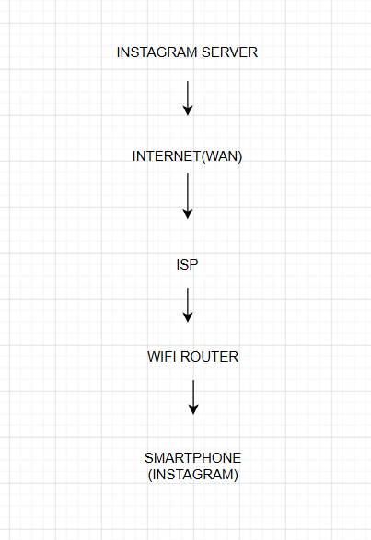

- Smartphone
- Wi-Fi Router
- ISP (Internet Service Provider)
- Internet (WAN)
- Instagram Server

TASK2: List 5 devices you use or see daily that are part of a network (for example: smartphone, smart TV, WiFi router, laptop, smartwatch). For each, write what type of network it connects to (LAN, WAN, PAN, etc.).
Device | Network Type
Smartphone | WAN (Internet), LAN (Wi-Fi)
Laptop | LAN, WAN
Smart TV | LAN, WAN
Wi-Fi Router | LAN, WAN
Smartwatch | PAN (Bluetooth), LAN (Wi-Fi)

TASK3: Explain the difference between the Internet and an intranet using an example from your college or a public WiFi you have used.
Internet | Intranet
The Internet is a public network that anyone can access. | An intranet is a private network used within an organization.
Example: Using YouTube or Instagram on public Wi-Fi. | Example: A college student portal Or like TOPS career centre portal

TASK4: Pick any one app you use (like WhatsApp, Zomato, or Flipkart) and describe, in 4-5 lines, how data travels from your device to their server and back when you perform a search inside the app.<br><br><em><strong>Hint:</strong> Mention the devices and networks involved, and what happens when you hit 'search'.</em>
- I open the WhatsApp app and search for a contact or message.
- The search request is sent from my phone to the Wi-Fi router.
- The router sends the request through the ISP and the Internet to the WhatsApp server.
- The WhatsApp server processes the request and finds the required data.
- The server sends the results back through the Internet, ISP, and router to my phone, where they are displayed in the app.

